  Australia | 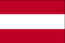  Austria | 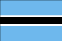  Botswana | 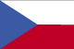  Czech Republic |   Finland
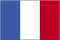  France | 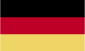  Germany | 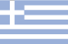  Greece |   Hong Kong |   Ireland
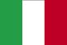  Italy |   Liechtenstein | 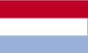  Luxembourg | 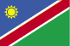  Namibia | 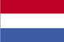  Netherlands
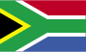  South Africa | 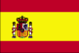  Spain | 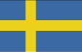  Sweden |   Switzerland | 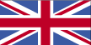  United Kingdom
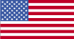  United States |   European Union | 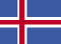  Iceland

